**EXPERIMENT 5**

JOSE THOMAS

ROLL NO:38

create table employee_exp5_CSEA_38(emp_id int primary key,empname varchar(20),dept varchar(20),salary int );

desc employee_exp5_CSEA_38;

table EMPLOYEE_EXP5_CSEA_38 created.

desc employee_exp5_CSEA_38

Name Null Type

------- -------- ------------

EMP_ID NOT NULL NUMBER(38)

EMPNAME VARCHAR2(20)

DEPT VARCHAR2(20)

SALARY NUMBER(38)

INSERT

create table employee_exp5_CSEA_38(emp_id int primary key,empname varchar(20),dept varchar(20),salary int );

desc employee_exp5_CSEA_38;

insert into employee_exp5_CSEA_38 values(1,'david smith','marketing',7500);

insert into employee_exp5_CSEA_38 values(2,'ayra','sales',8500);

insert into employee_exp5_CSEA_38 values(3,'charles brown','hr',9000);

insert into employee_exp5_CSEA_38 values(4,'oziya','production',5000);

insert into employee_exp5_CSEA_38 values(5,'ananya','sales',7000);

select * from employee_exp5_CSEA_38;

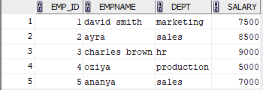

1)

select * from employee_exp5_CSEA_38 where salary>7000;

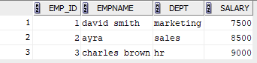

2)

update employee_exp5_CSEA_38 set salary=8200 where empname='david smith';

select * from employee_exp5_CSEA_38;

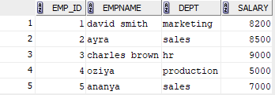

3)

insert into employee_exp5_CSEA_38 values(6,'daniel harris','production',6700);

select * from employee_exp5_CSEA_38;

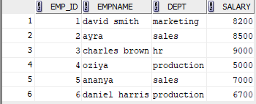

4)

delete from employee_exp5_CSEA_38 where emp_id=3;

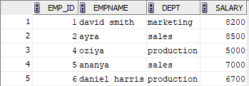

5)

select empname from employee_exp5_CSEA_38 where not(empname like 'd%' OR empname like 'o%');

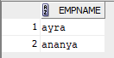

6)

select dept,sum(salary) as total_salary from employee_exp5_CSEA_38 group by dept;

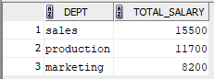

7)

update employee_exp5_CSEA_38 set salary=salary+(0.05*salary)where dept='production';

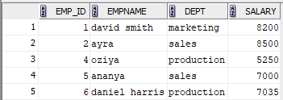

8)

DELETE from employee_exp5_CSEA_38 where salary<7000;

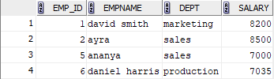

9)

select empname,salary from employee_exp5_CSEA_38 where salary=(select min(salary)from employee_exp5_CSEA_38);



10)

update employee_exp5_CSEA_38 set salary=8200 where dept='marketing';

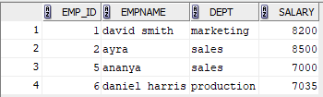

11)

select empname from employee_exp5_CSEA_38 where empname like 'a%';

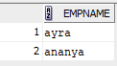

12)

select empname from employee_exp5_CSEA_38 where empname like '%it%';



13)

select UPPER(dept)from employee_exp5_CSEA_38;

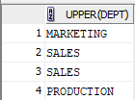

14)

select * from employee_exp5_CSEA_38 where dept like 'm%r%' and dept like '%ket%';



15)

select distinct upper(reverse(dept))from employee_exp5_CSEA_38;

